THE CHECKERED EYE PROJECT

409 Peirson Avenue, Port Elgin, ON, N0H 2C1

(519) 389-4956 info@checkeredeye.com

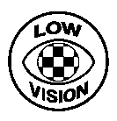

Dear Chamber of Commerce,

The checkered eye is a wearable symbol with which people may communicate their partial blindness, also known as low vision.

The Checkered Eye Project (CEP) works to increase awareness of low vision, and the checkered eye. The new symbol is in use in many parts of Canada, the U.S., and New Zealand.

Since customer care is improved by understanding the diverse needs of clientele, it’s useful for chamber members to be aware of this new emblem and its message.

To inform members, you may simply refer them to the website. We hope you will also pass this on through any publications you distribute. For awareness purposes, you may print items from the website, or request copies.

Sincerely,

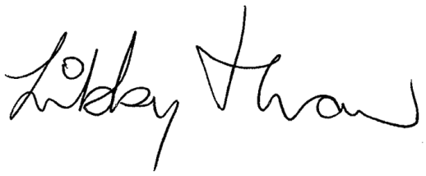

Libby Thaw

www.checkeredeye.com